[ZANG] - [Chuanjie]

Student ID: 699382953

[chuanjiezang@gmail.com](mailto:chuanjiezang@gmail.com)

Question 1: Assume hot dogs come in packages of 10, and hotdog buns come in packages of 8. Write a program that calculates the number of packages of hot dogs and the number of packages of hot dog buns needed for a cookout, with minimum amount of leftovers. The program should ask the user for the number of people attending the cookout and the number of hot dogs each person will be given. The program should display the following details:

• The minimum number of packages of hot dogs required.

• The minimum number of packages of hot dog buns required

• The number of hot dogs that will be left over

• The number of hot dog buns that will be left over (10 Points)

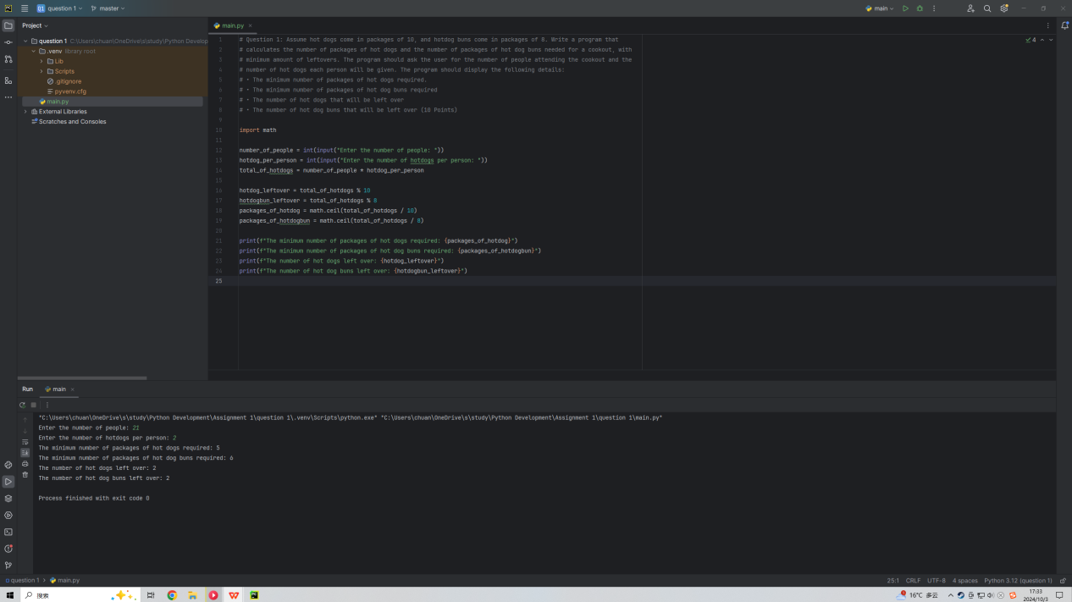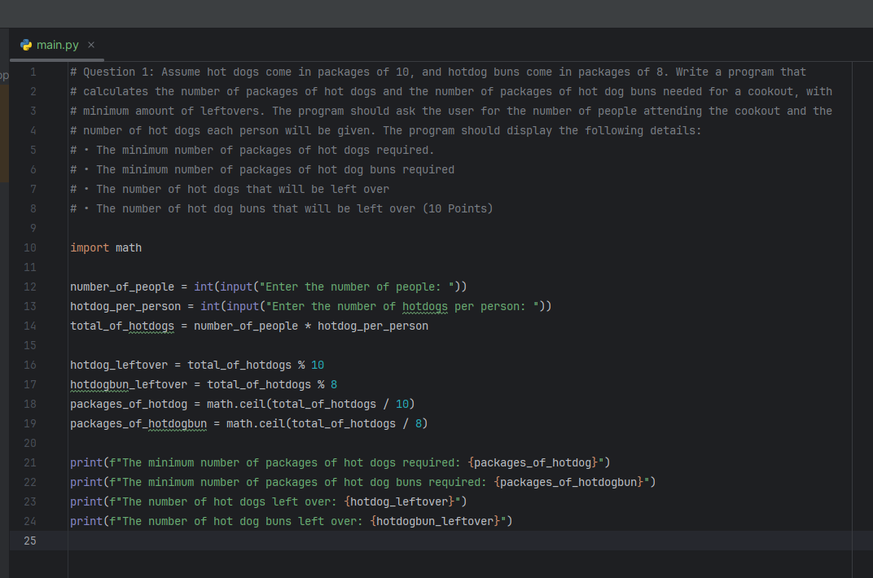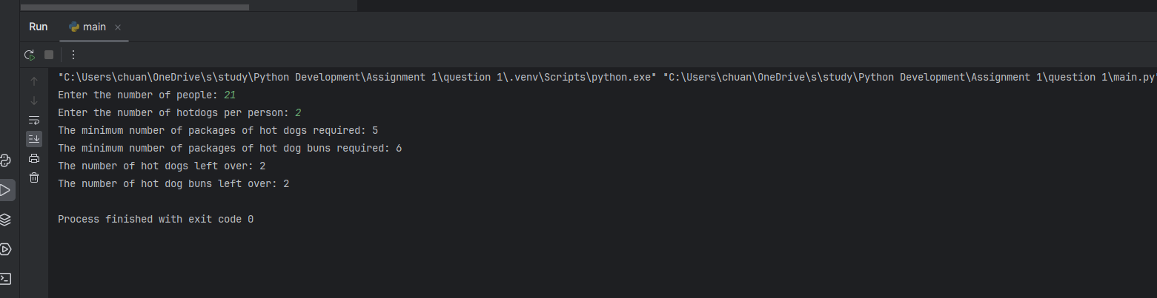

Question 2: Write a program that asks the user to enter the monthly costs for the following expenses incurred from operating his or her automobile: loan payment, insurance, gas, and maintenance. The program should then display the total monthly costs for these expenses and the total annual costs for these expenses. (10 marks)

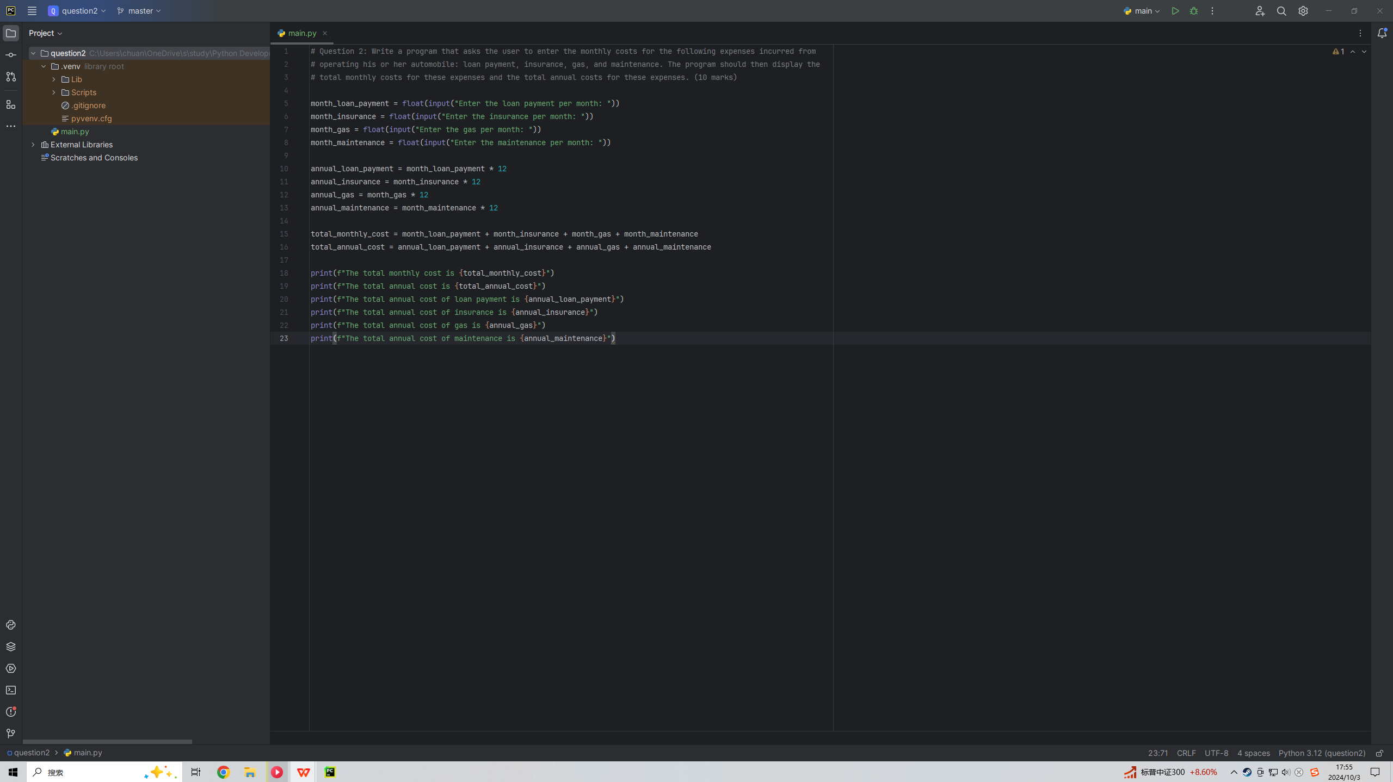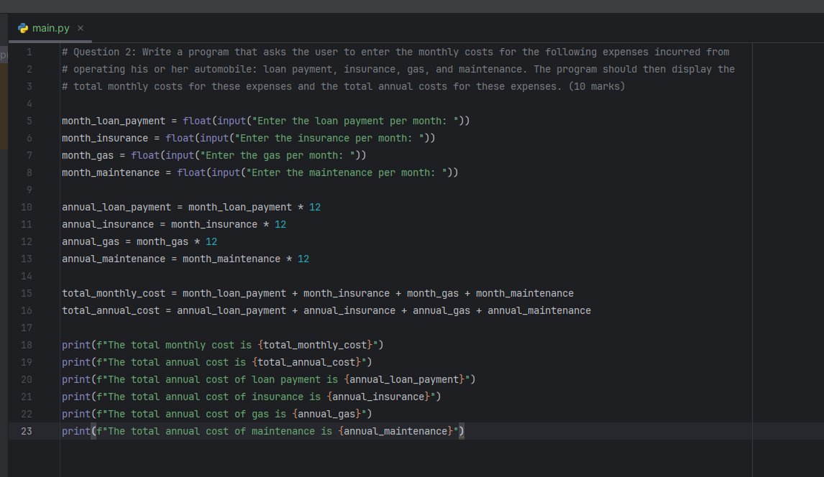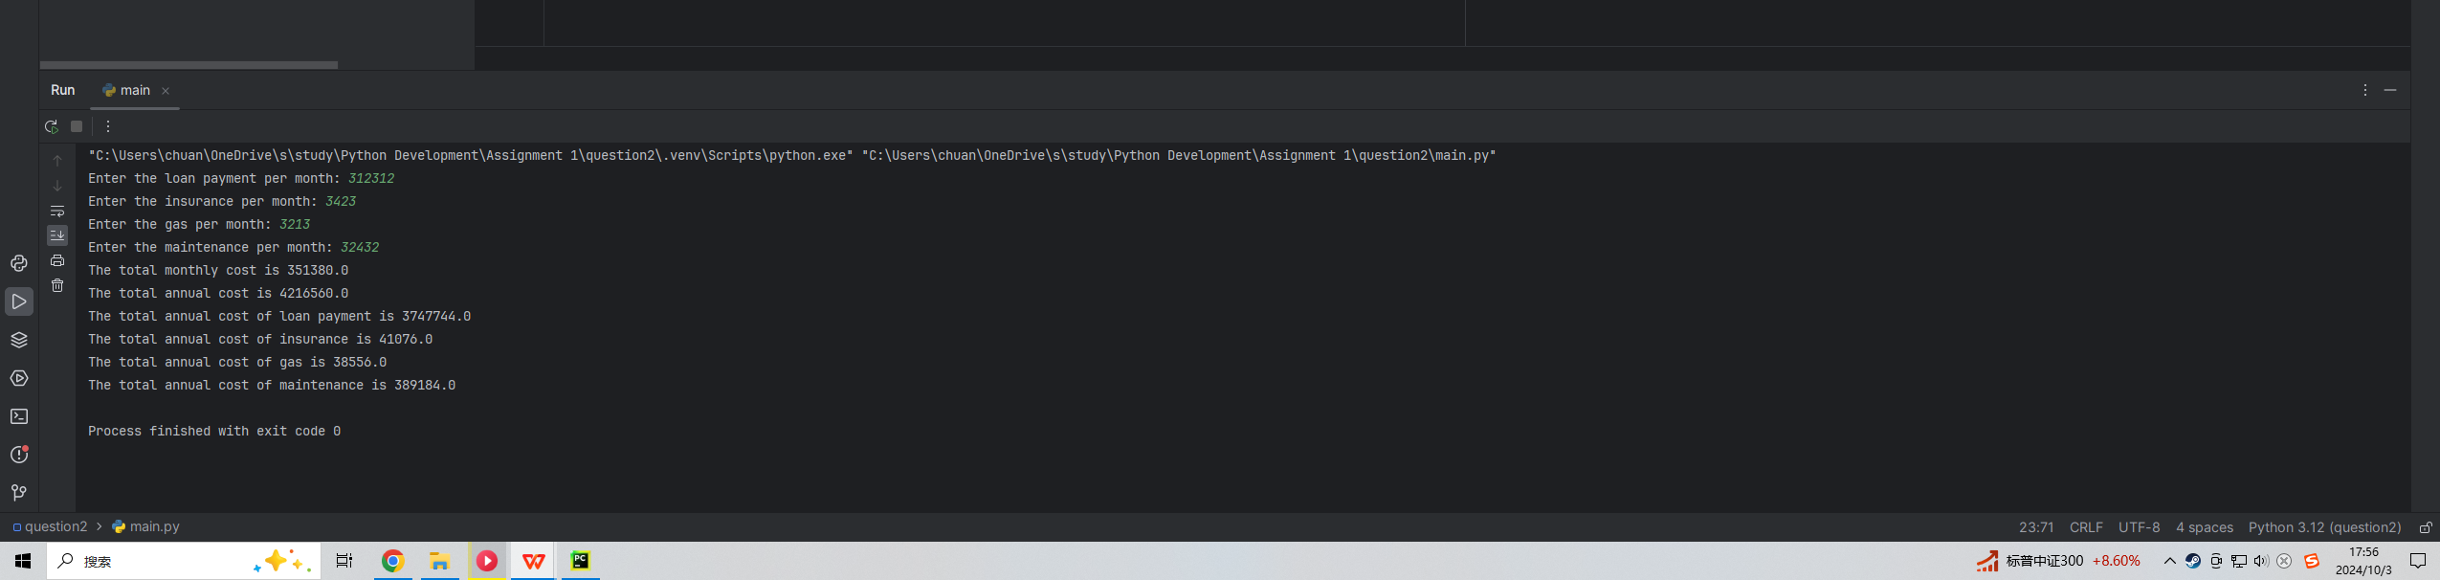

Question 3: A painting company has determined that for every 112 square feet of wall space, one gallon of paint is required. The company charges $25.00 per hour for labour. Write a program that asks the user to enter the number of square feet of wall space to be painted and the price of the paint per gallon.

The program should then display the following data.

• The number of gallons of paint required

• The cost of the paint

• The hours of labour required to complete the job

• The cost of the labour to complete the job

• The total cost of the paint job.

Assume that the program will run only once for each estimate. (10 marks)

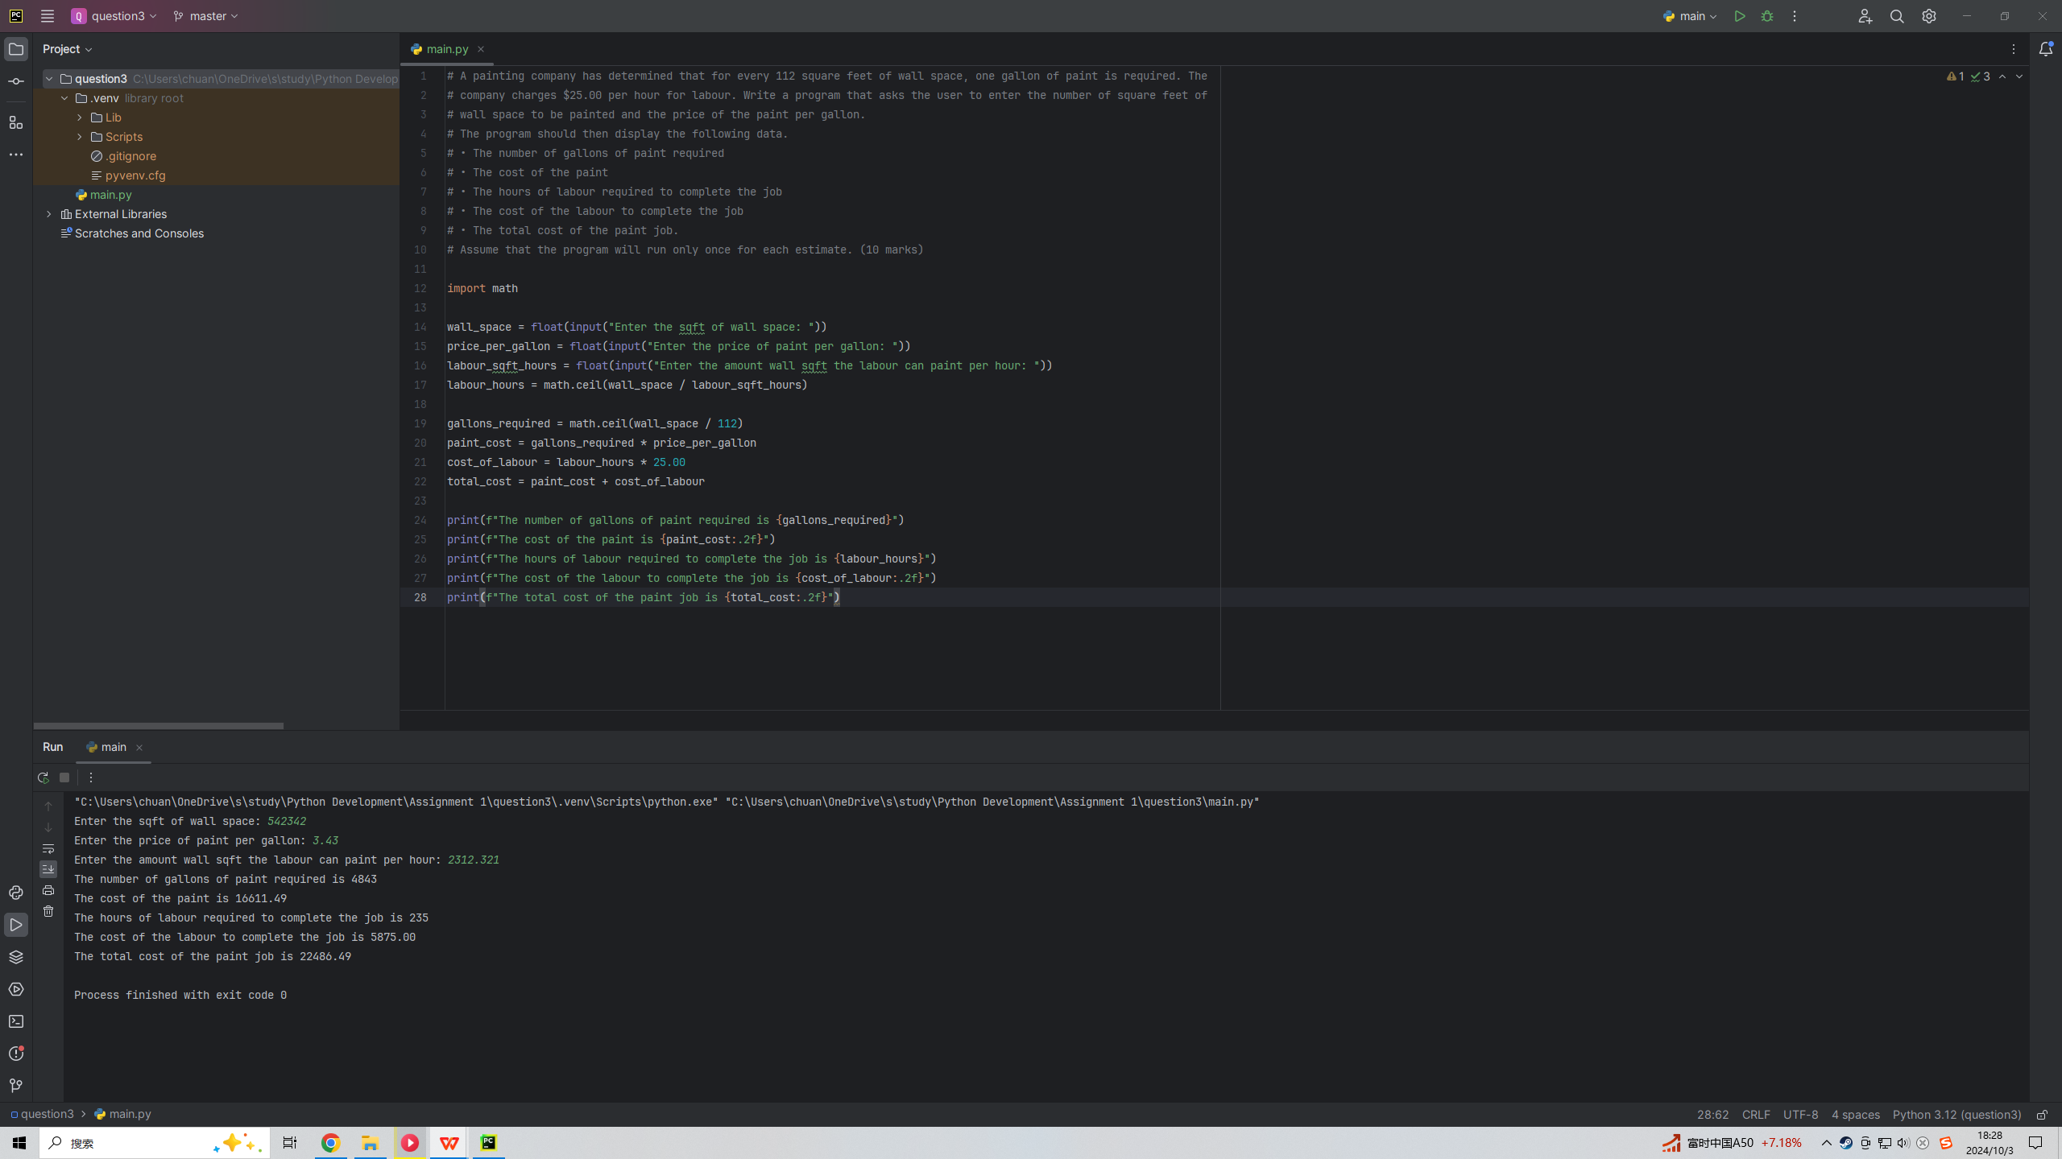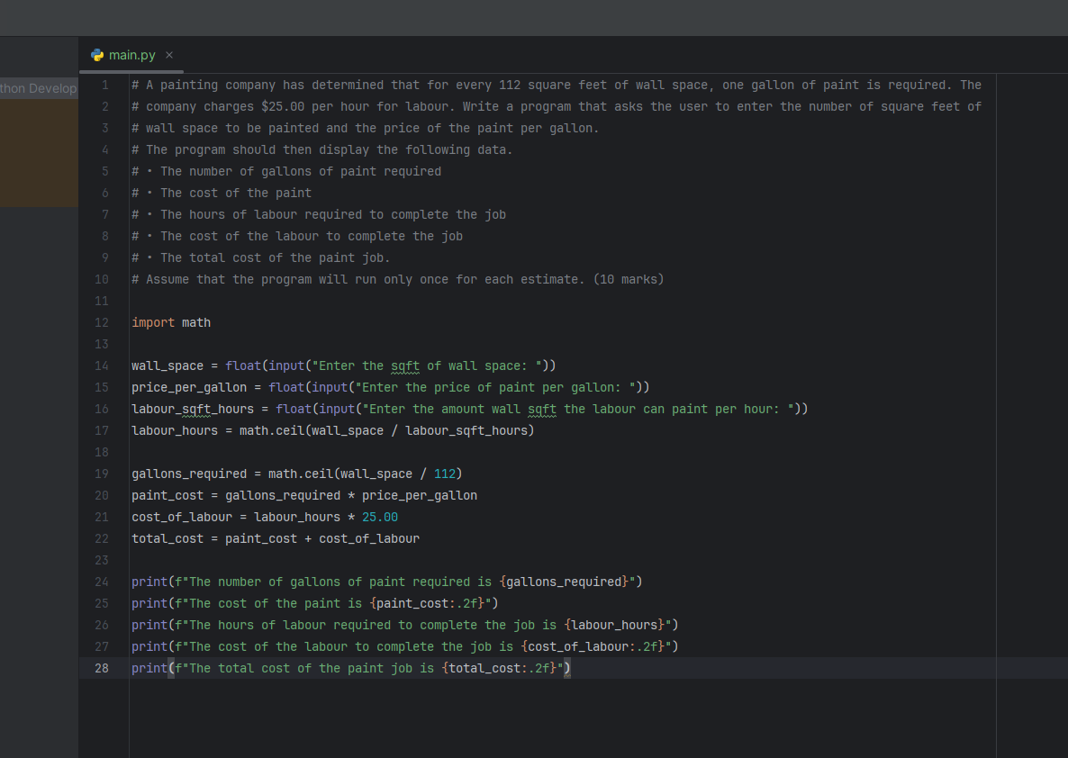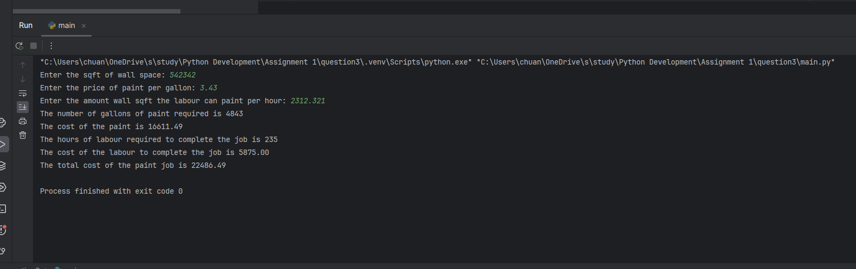

Question 4: A Personal Fitness tracker is a wearable device that tracks one’s physical activity, calories burned, heart rate, sleeping patterns and so on. One common physical activity that is tracked is the number

of steps that you take each day. The File named Steps.txt contains the number of steps that a user has made each day for an entire year (Jan 1 to Dec 31) Write a program that reads the file, then displays the average number of steps taken for each month. Assume the data is from a year that is not a leap year, therefore, February has 28 days. The program should then count the number of days in the year that the user has made 10,000 steps or more and display the number of days with 10000

or more steps. (10 marks)

